**Study Card: Dalton’s Law of Partial Pressure**

**Dalton’s Law of Partial Pressure**

The total pressure of a gas mixture is the sum of the pressure that each individual gas would exert if it were alone in a container having the same temperature and pressure.

**”**

**“**

**Let’s Suppose …**

A mixture of gases A, B, and C are in a 10.0 L container at 300.0 K. There are 2.00 mol of A, 5.00 mol of B, and 3.00 mol of C in the mixture. What is the total pressure of the gas mixture?

**First**, determine the pressure of the individual gases as if they were alone. See work at right.

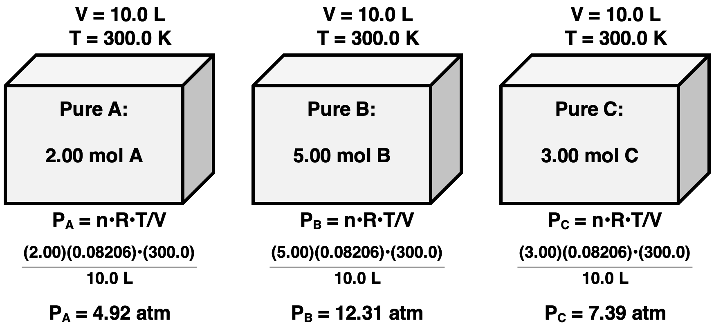

**Second**, sum the individual pressures to determine the total pressure.

Ptotal = PA + PB + PC = 4.92 atm + 12.31 atm + 7.39 atm

**Ptotal = 24.62 atm**

**Get This!**

All gases behave the same. Their identity (O2, N2, CH4) does not affect how they behave.

**It’s as if …**

There’s only 1 gas …

10.00 mol at 300 K in a 10.0 L container.

PTotal =

(10.00 mol)•(0.08206)•(300)/(10.0)

**PTotal = 24.62 atm**

**Mixing Gases**

Unequal volumes of He and Ne mix when the valve is opened. Each gas undergoes a *Boyle’s Law expansion* to a 4.0 L volume. This lowers the individual pressure of each gas. Use Boyle’s Law to calculate individual pressure of each gas. Then calculate Ptotal.

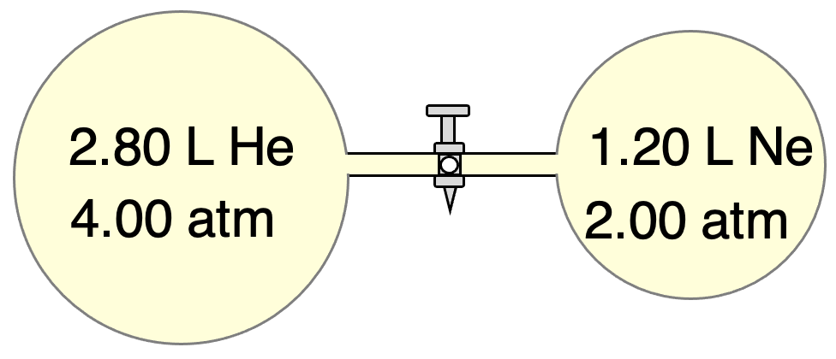

**For He:**

Known: P1 = 4.00 atm

V1 = 2.80 L

V2 = 4.00 L

Use P2 = P1•V1 / V2

P2 = (4.00 atm)•(2.80 L)/(4.00 L)

P2 = **PHe = 2.80 atm**

**For Ne:**

Known: P1 = 2.00 atm

V1 = 1.20 L

V2 = 4.00 L

Use P2 = P1•V1 / V2

P2 = (2.00 atm)•(1.20 L)/(4.00 L)

P2 = **PNe = 0.600 atm**

**Calculate Ptotal**

Ptotal = PHe + PNe

Ptotal = 2.80 atm + 0.60 atm

**Ptotal = 3.40 atm**

**Find it all at**:

www.physicsclassroom.com

Chemistry Tutorial

🡺 Chapter 10

🡺 Lesson 2g

**There’s much more help online … more explanations, examples, and practice with feedback.**





PTotal = nTotal•R•T/V

PTotal = (10.00 mol)•(0.08206)•(300)/(10.0)

**PTotal = 24.62 atm**

**It’s as if …**

There’s only 1 gas …

10.00 mol at 300 K in a 10.0 L container.

PTotal =

(10.00 mol)•(0.08206)•(300)/(10.0)

**PTotal = 24.62 atm**

**AAA**

AAA

**AAAA**

AAAA

**Source**:

www.physicsclassroom.com

Chemistry Tutorial

🡺 Chapter 10

🡺 Lesson 2g



**Source**:

www.physicsclassroom.com

Chemistry Tutorial

🡺 Chapter 10

🡺 Lesson 2g



**Source**:

www.physicsclassroom.com

Chemistry Tutorial

🡺 Chapter 10

🡺 Lesson 2g

